EDA Report
File 1: Customer_churn_eda.py
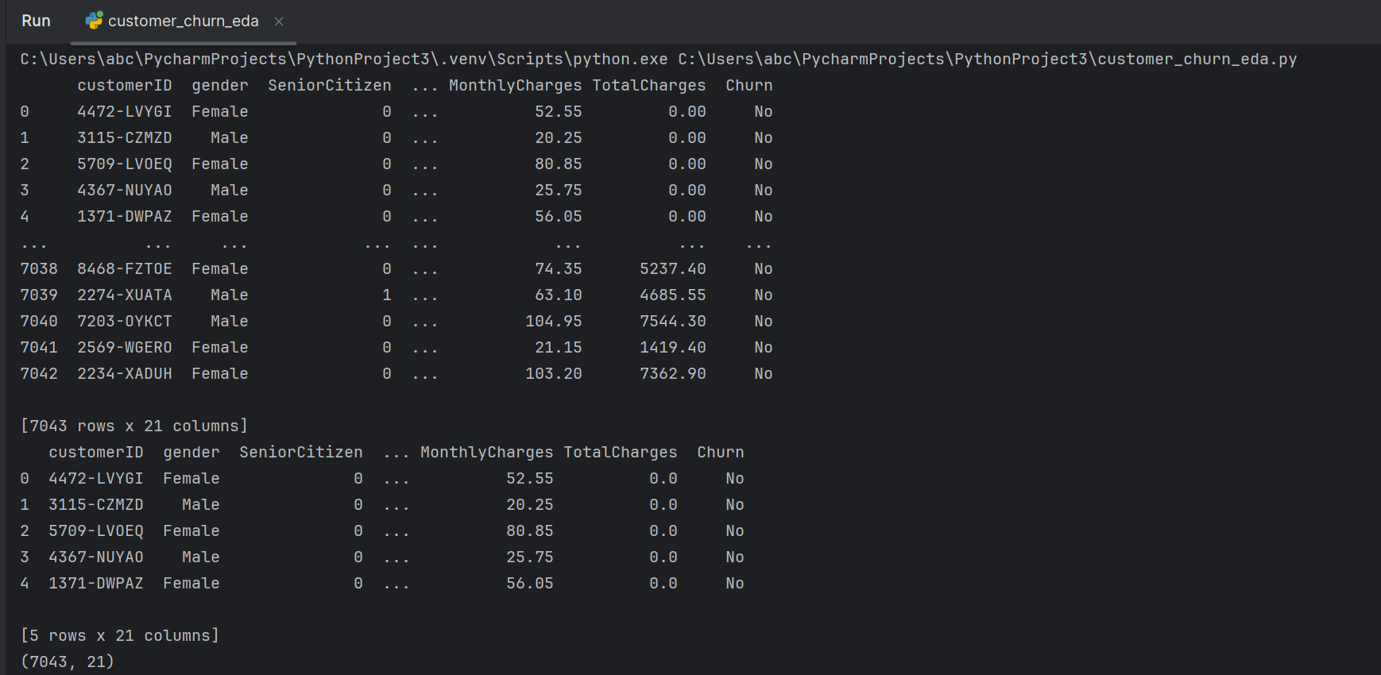
The Telco Customer Churn dataset was loaded into Python and examined before starting the analysis. The first and last five records were viewed to verify that the data was imported correctly. The dataset contains customer demographics, service usage, billing information, and churn status. It consists of 7,043 records and 21 variables making it suitable for analyzing customer behavior and identifying factors that influence customer churn. This dataset will also be used for churn prediction and customer lifetime value (LTV) modeling in later stages of the project.
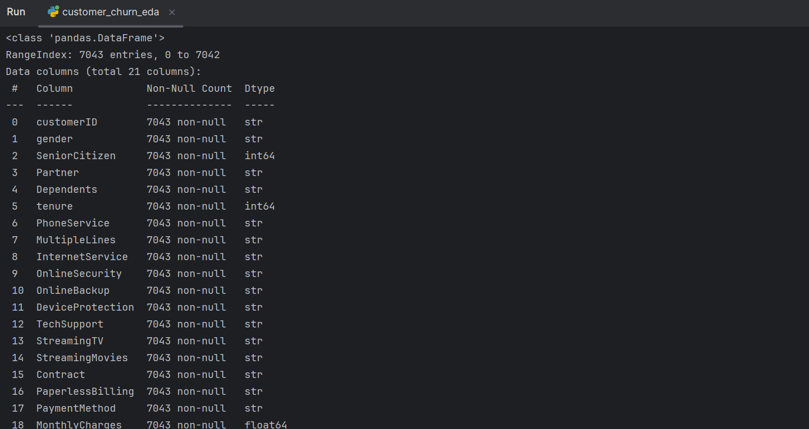
The dataset contains 21 columns and 7,043 observations. All columns have 7,043 non-null values, indicating that there are no missing records. The dataset consists of categorical and numerical variables. Customer-related information such as gender, contract type, internet service, and payment method are stored as categorical variables, while tenure, monthly charges, and total charges are stored as numerical variables. The dataset structure is suitable for exploratory data analysis and machine learning applications.

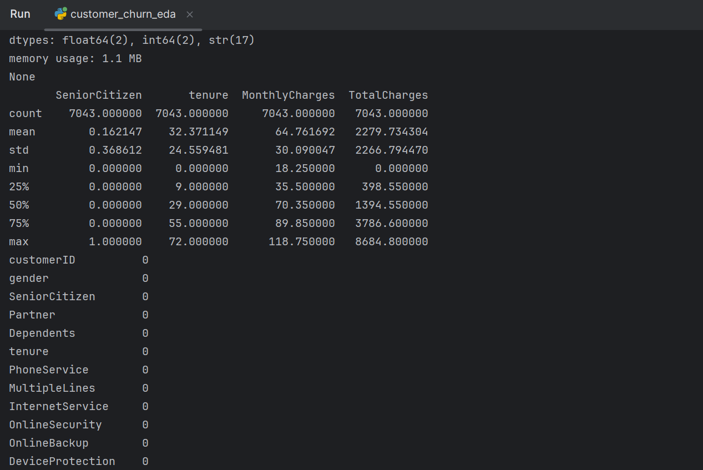
Descriptive statistics were generated for the numerical variables: SeniorCitizen, Tenure, MonthlyCharges, and TotalCharges. The average customer tenure is approximately 32 months indicating that customers typically remain with the company for a moderate period. Monthly charges average around 64.76 while the average total charges are approximately 2279.73. The maximum tenure observed is 72 months suggesting that some customers have maintained long-term relationships with the company. The wide range and standard deviation of TotalCharges indicate significant variation in customer spending behavior.
The median tenure is 29 months, meaning that half of the customers have been with the company for less than 29 months and half for more. Similarly, the median monthly charge is 70.35, showing that many customers pay close to this amount for services. The distribution of total charges suggests that customers who remain longer with the company tend to generate substantially higher revenue.

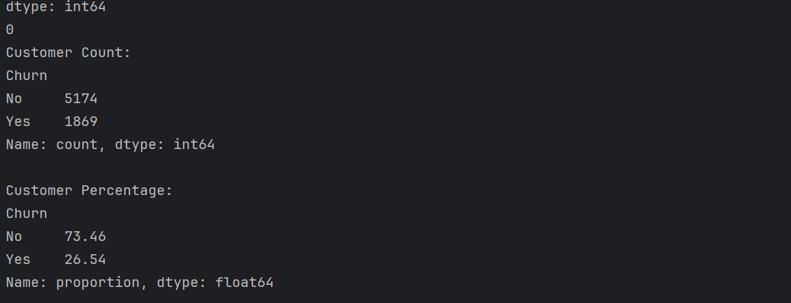
To understand the distribution of customer churn, the number and percentage of customers who stayed and those who left the company were analyzed. The results show that 5174 customers (73.46%) did not churn, while 1869 customers (26.54%) churned. This indicates that most customers have remained with the company, but a considerable number of customers have discontinued the service.
The churn rate of 26.54% suggests that nearly one out of every four customers has left the company. Although customer retention is relatively high, reducing churn remains important for improving customer loyalty and business performance. These findings highlight the need to identify the factors that contribute to customer churn so that effective retention strategies can be developed in the later stages of the project.
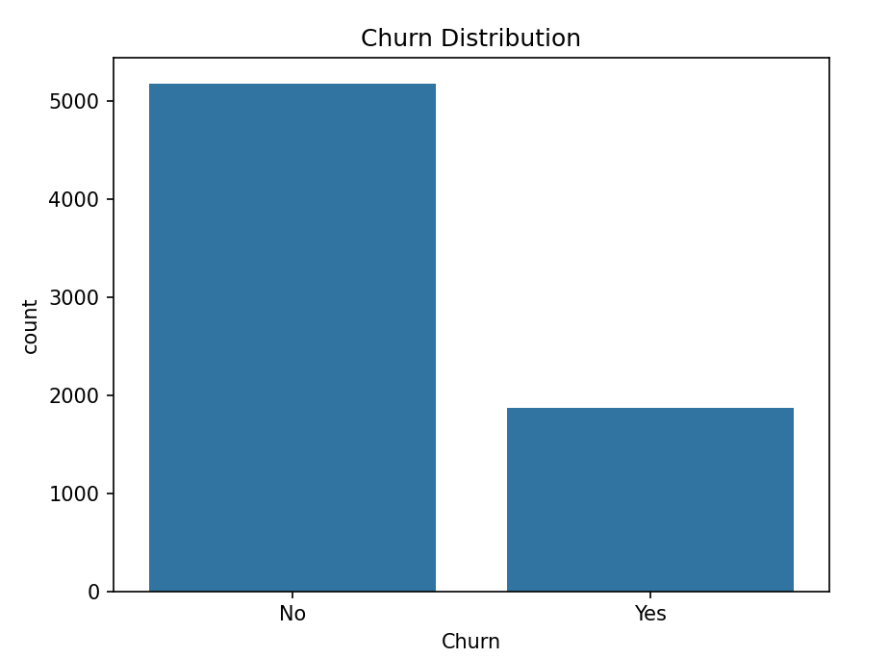
The graph shows that most customers have remained with the company, while a smaller number have churned. Out of 7043 customers, 5174 (73.46%) did not churn and 1869 (26.54%) churned. Although customer retention is high, the churn rate is still significant and should be analyzed further to identify the factors influencing customer departure.
Numerical Variable Analysis (Tenure, Monthly Charges, and Total Charges)
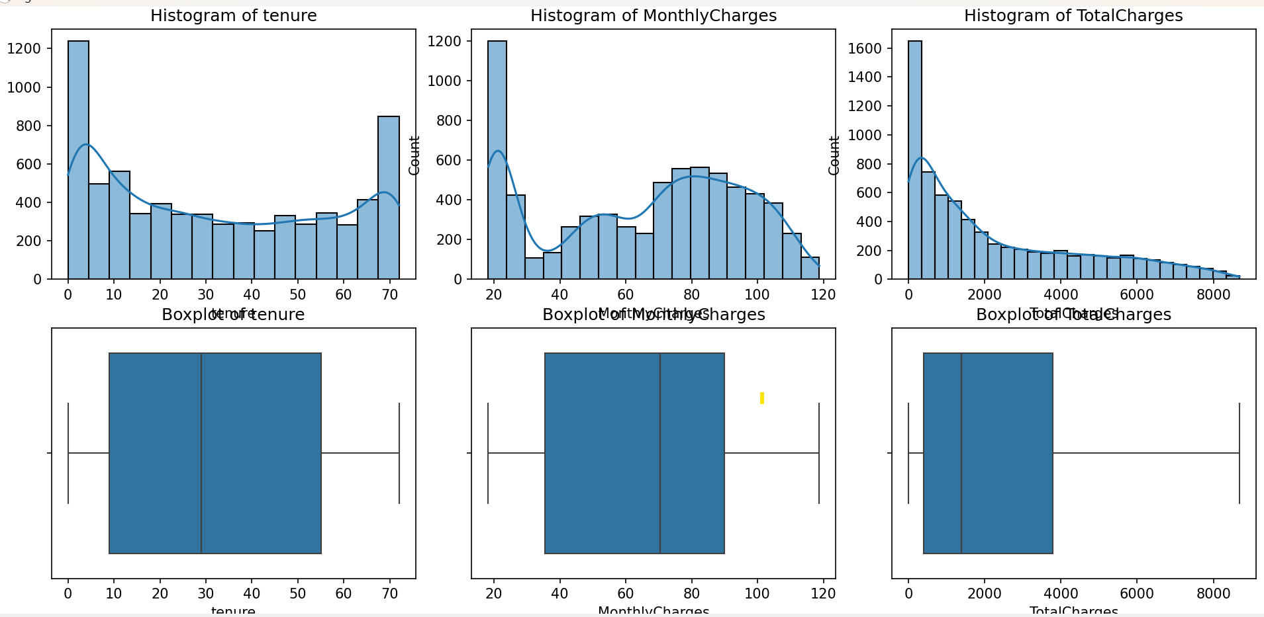
The histograms and boxplots were used to understand the distribution of the numerical variables which is Tenure, Monthly Charges, and Total Charges. The tenure distribution shows that the dataset contains both new and long-term customers, with customer tenure ranging from 0 to 72 months. The monthly charges are spread across different price ranges indicating that customers subscribe to a variety of service plans. The total charges distribution is positively skewed meaning that most customers have lower total charges while a smaller number of customers have accumulated higher charges over time.
The boxplots provide additional insight into the spread of the data. The median tenure is around 29 months, while the median monthly charge is approximately 70. Customers with longer tenure generally accumulate higher total charges, which is reflected in the wide range of the Total Charges variable. No significant outliers are visible in the boxplots, suggesting that the numerical variables are reasonably distributed and suitable for further analysis and predictive modeling.

